



**Installing Jira**

**Applications on Ubuntu**

Jira Software Data Center helps the world’s best agile teams plan, track, and release great software at scale. You can check out [atlassian/jira-software](http://hub.docker.com/r/atlassian/jira-software/) on Docker Hub and learn more about Jira Software at [https://www.atlassian.com/software/jira.](https://www.atlassian.com/software/jira)

We will be using an Ubuntu machine for Jira setup and we will use Docker for installation.

To get started with Jira Software Data center, you can either use a data volume, or a named volume. In this example, we'll be using named volumes.

Run the following command to create a name volume and mount it on the localhost: docker volume create --name jiraVolume

docker run -v jiraVolume:/var/atlassian/application-data/jira \

--name="jira" -d \

-p 8080:8080 atlassian/jira-software

Jira is now available on

[http://localhost:808](http://localhost:8080/)

[0](http://localhost:8080/)

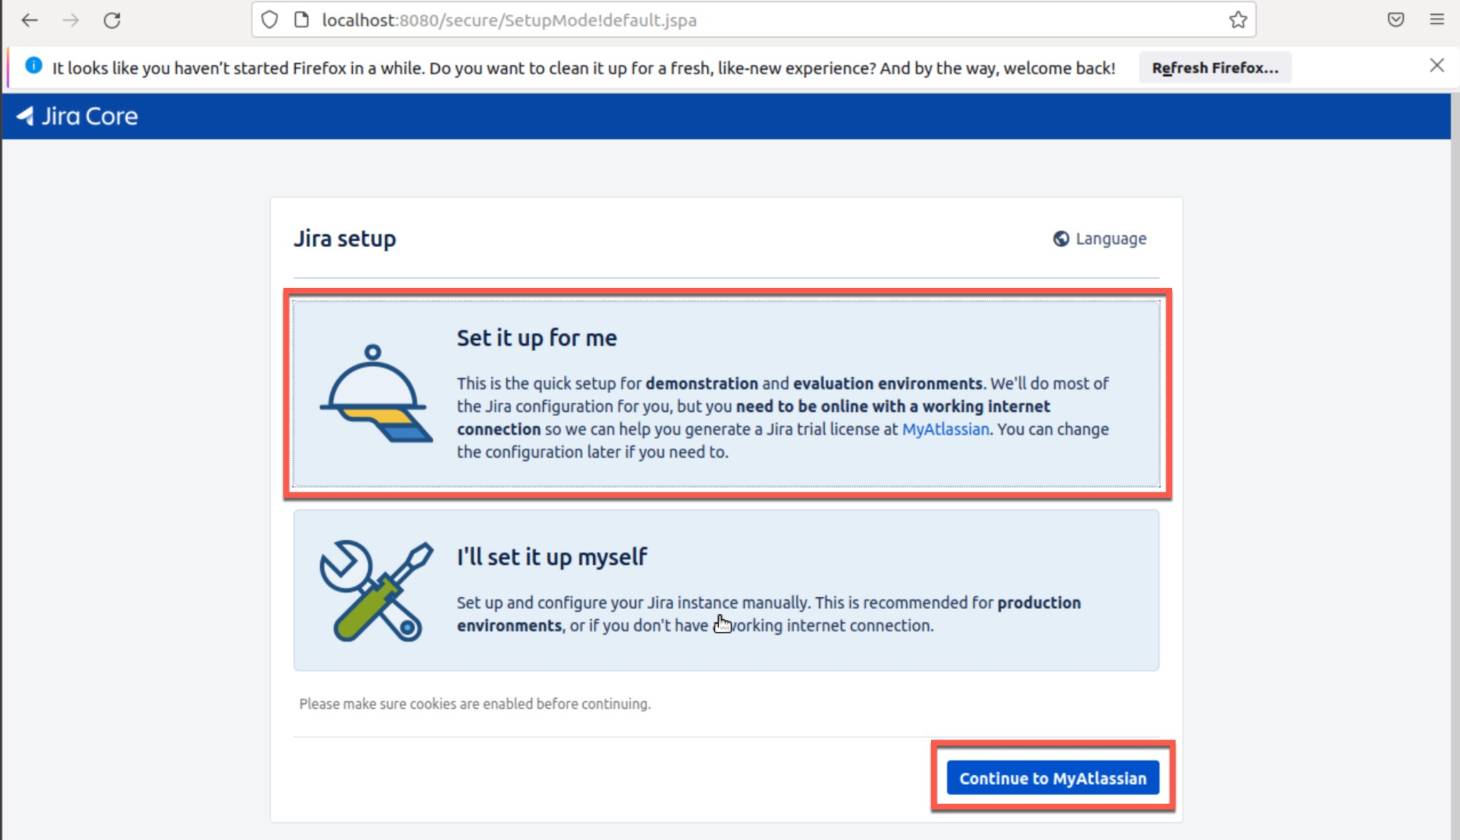

Click on **Continue to MyAtlassian**. It will take you to the Atlassian login screen where you can enter your email address to login/register using email ID.

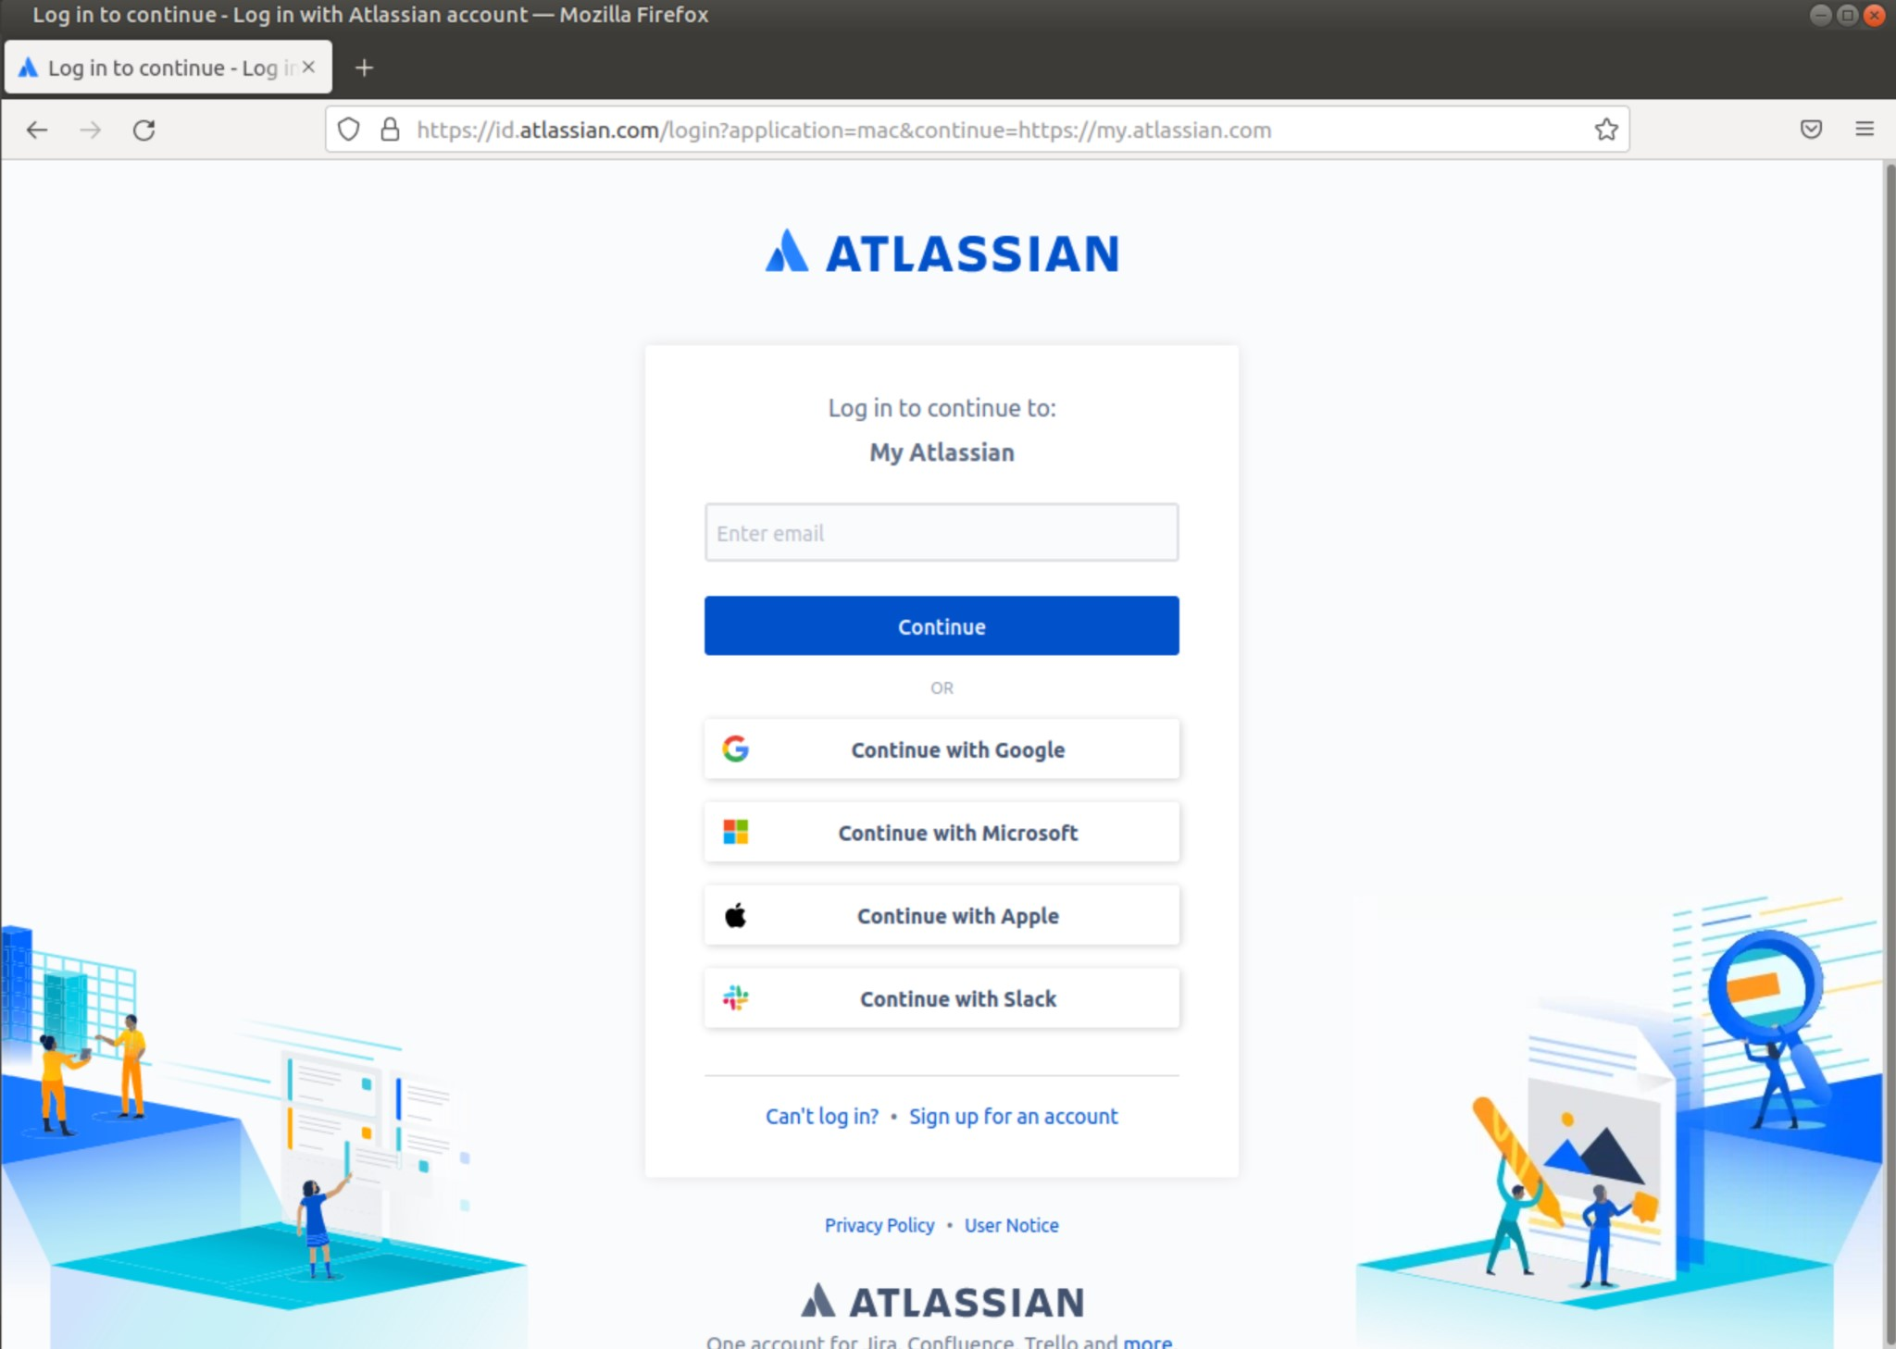

Once you have logged-in to your Atlassian account, it will ask you to create a license. Just click on **Generate License** as shown below:

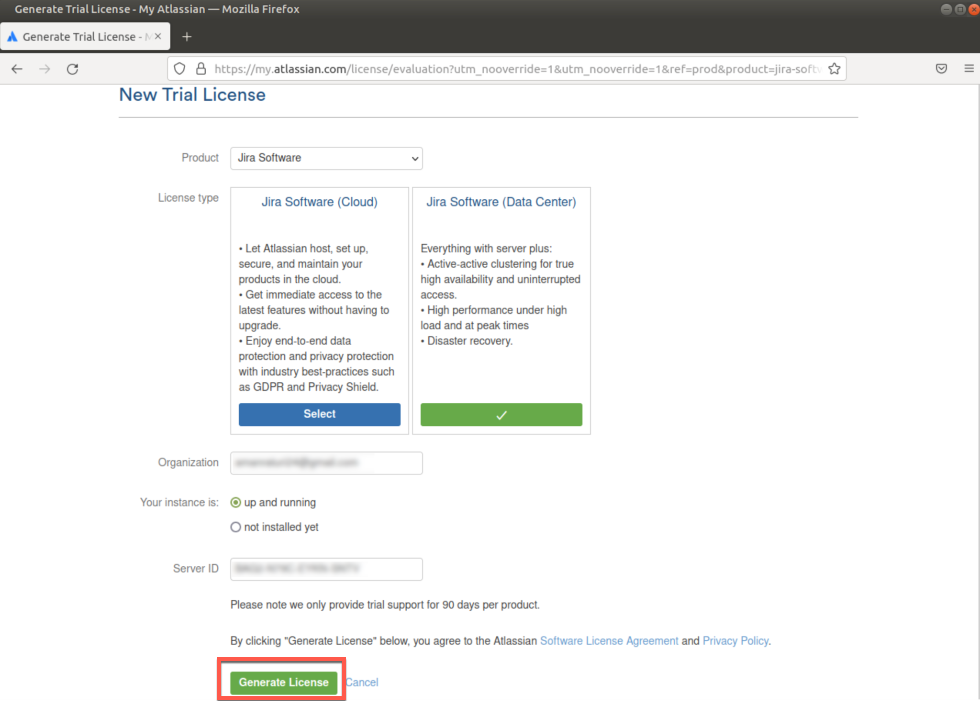

On the pop-up message, click on **Yes** for confirming that you are installing a license for a localhost server.

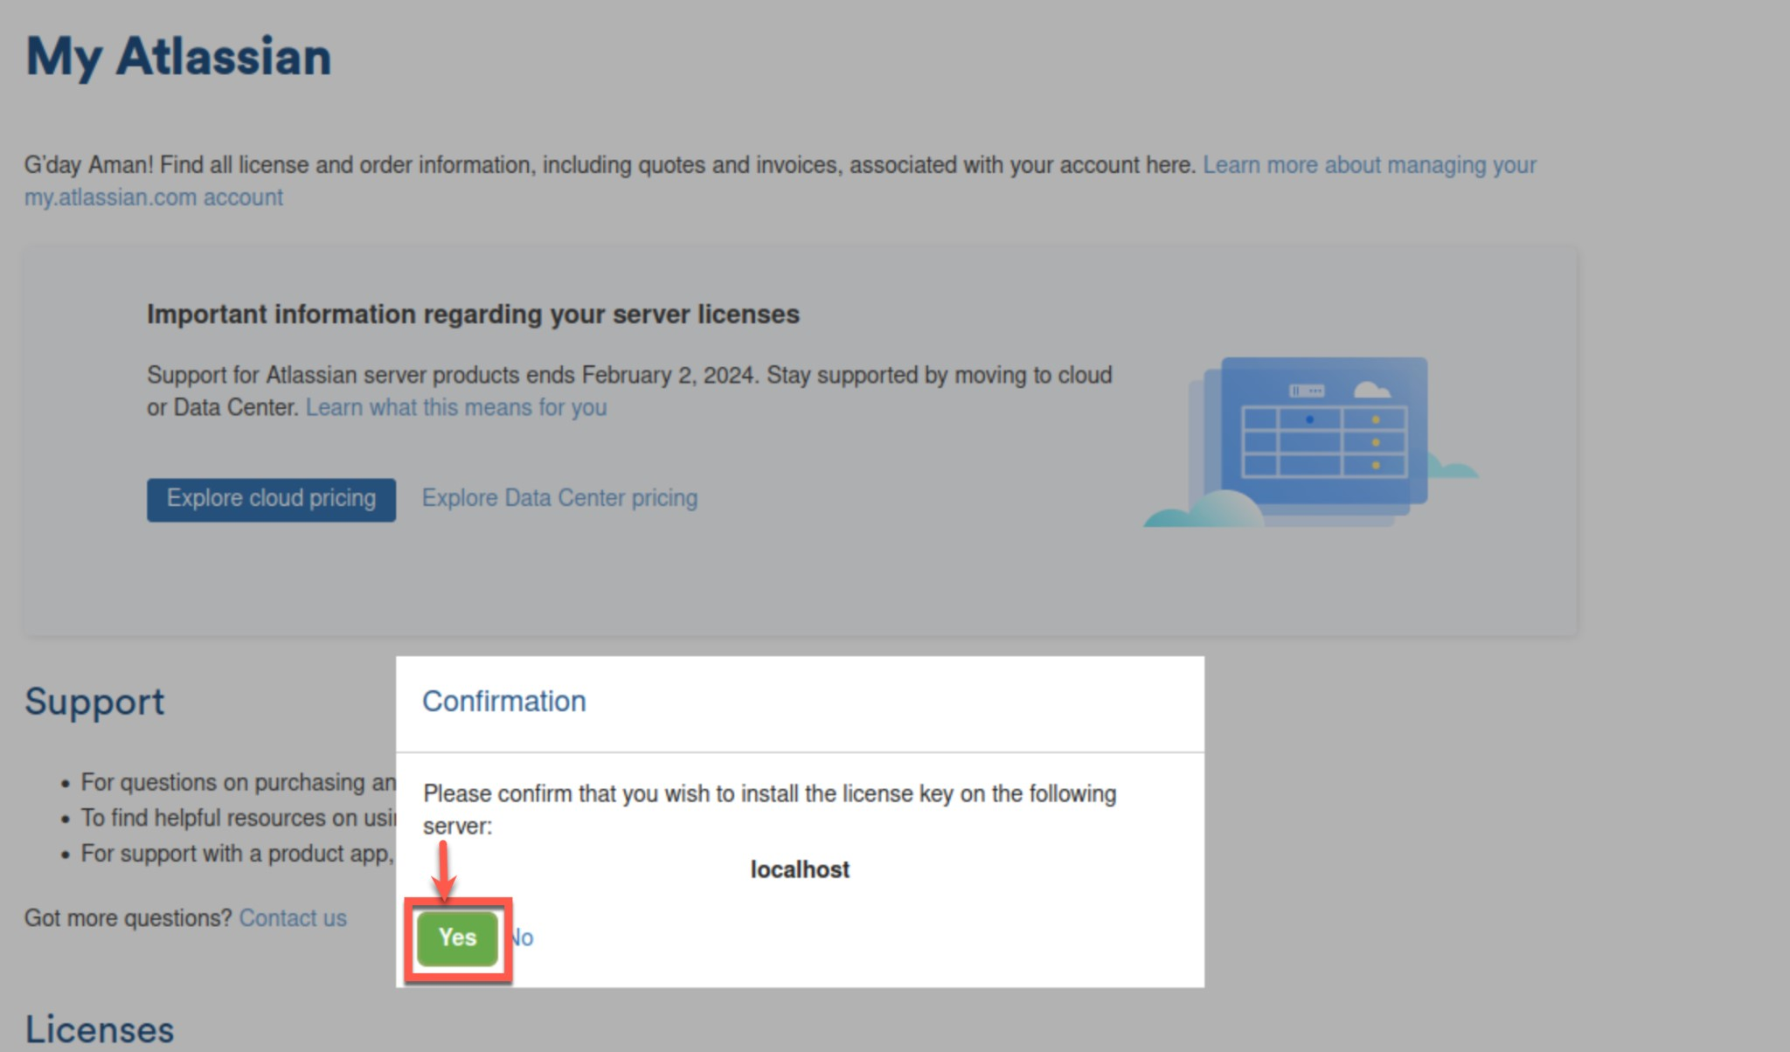

For Administrator account setup, enter your email address, username and password for verification and then click on **Next**.

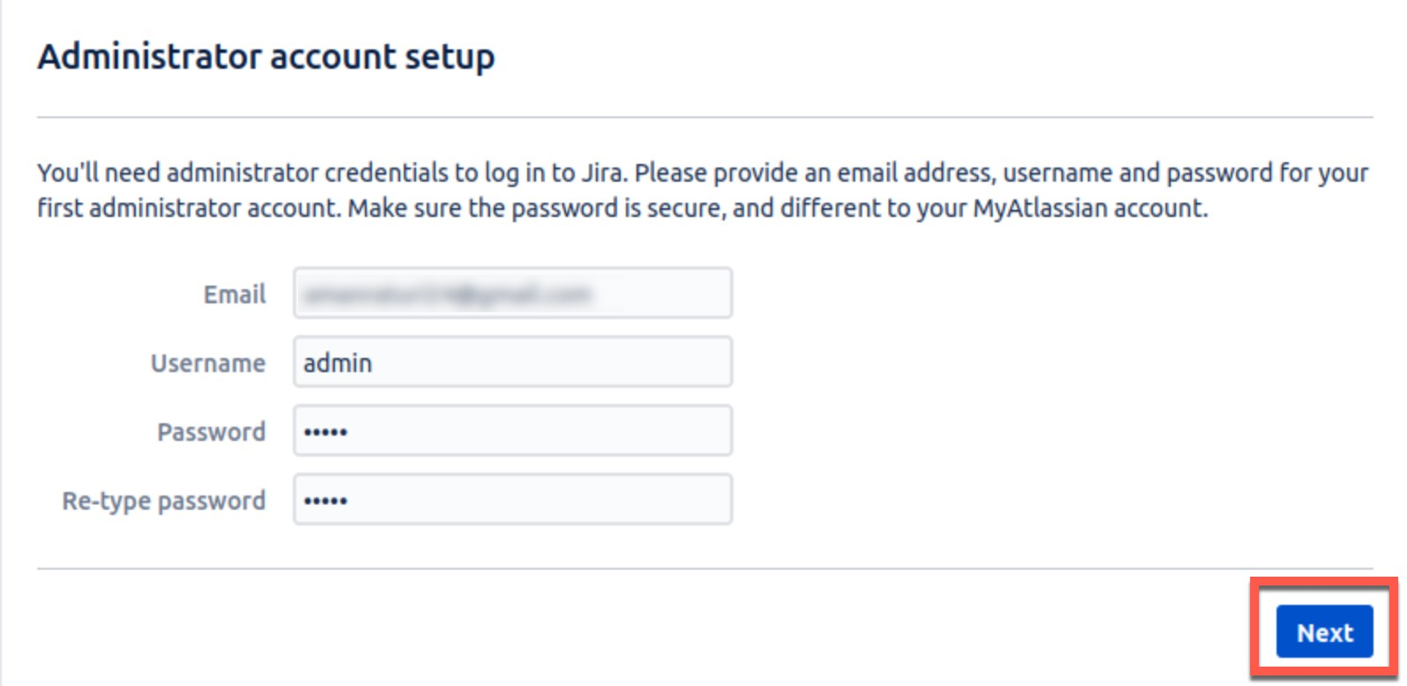

Setting up a new Jira instance would take around 2-3 minutes to complete.

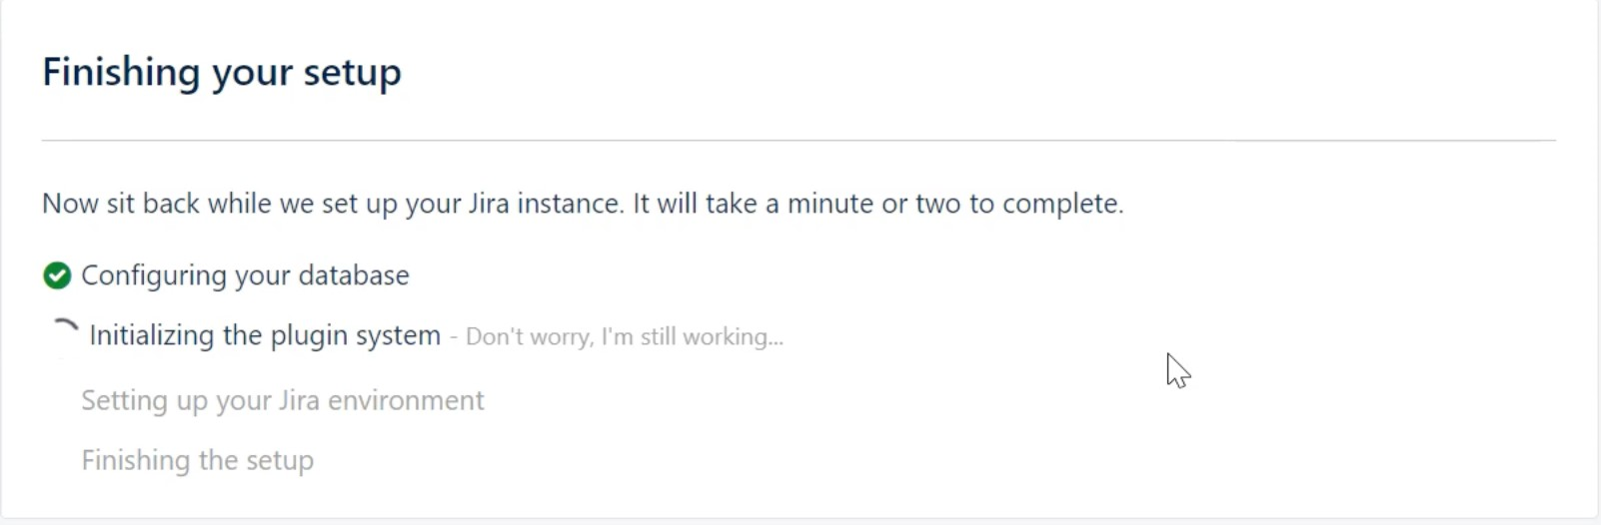

Once the setup is completed, just click on **Let’s get started**.

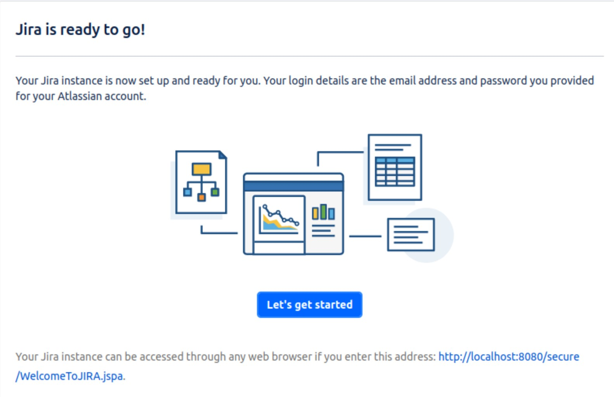

Choose the language of your choice, then click **Continue**.

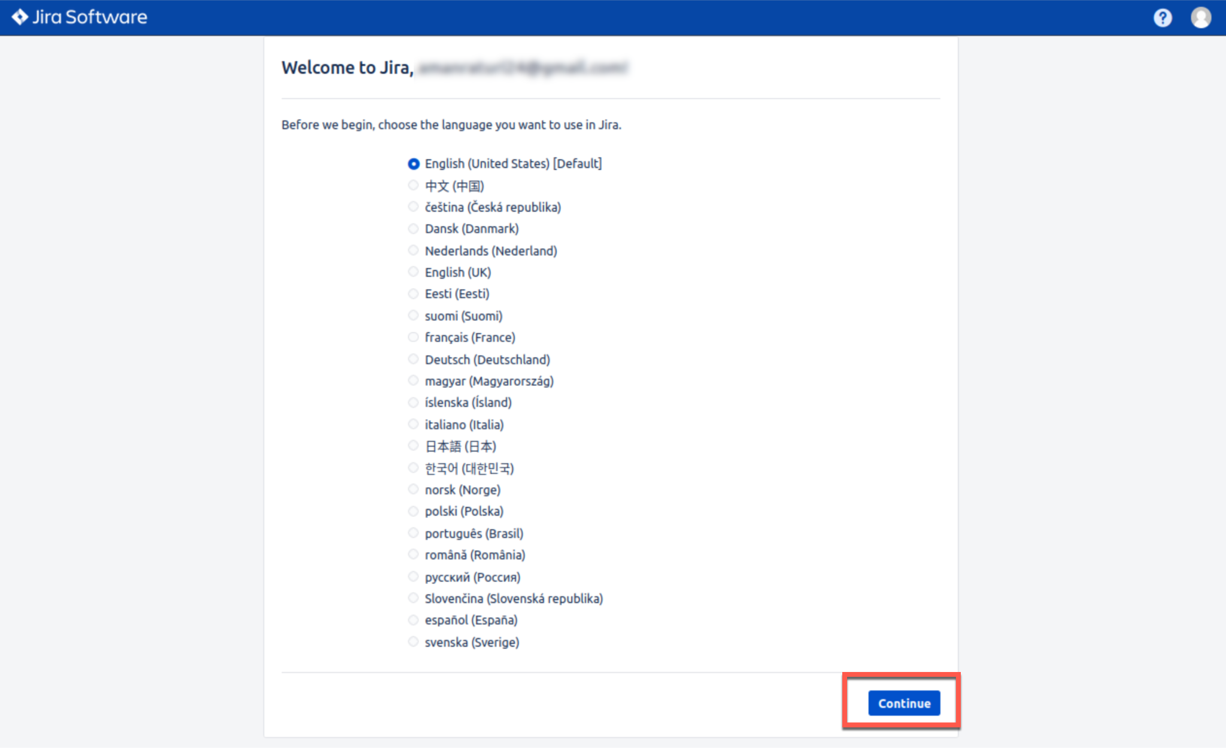

Choose your Avatar and click on **Next**.

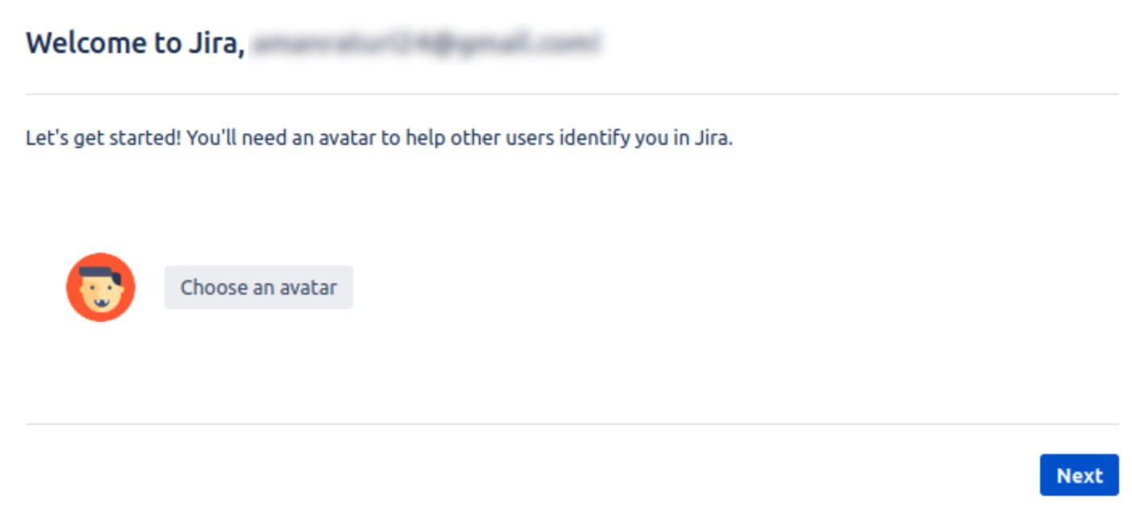

You can now see your JIRA dashboard!

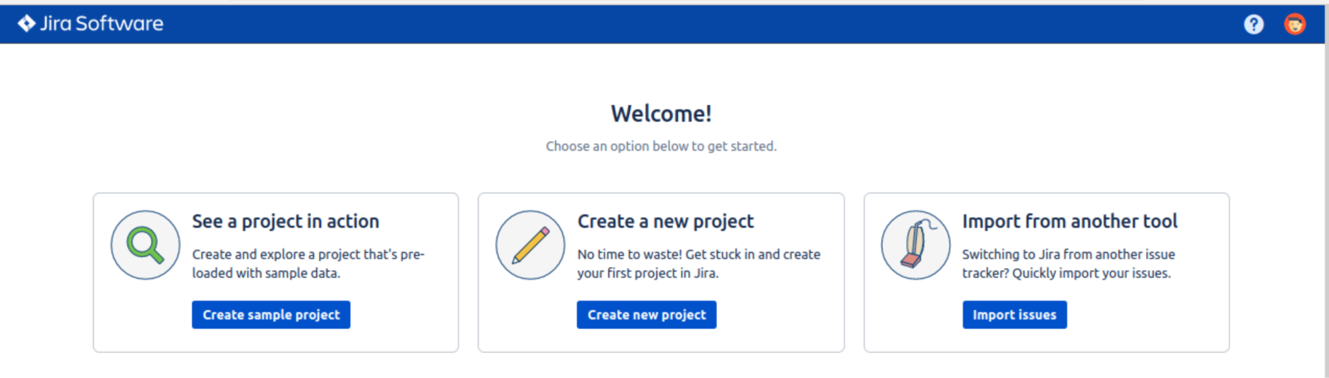

To create a sample project for Scrum software development, select the **Scrum software development** in **Software** tab and then click on **Next**.

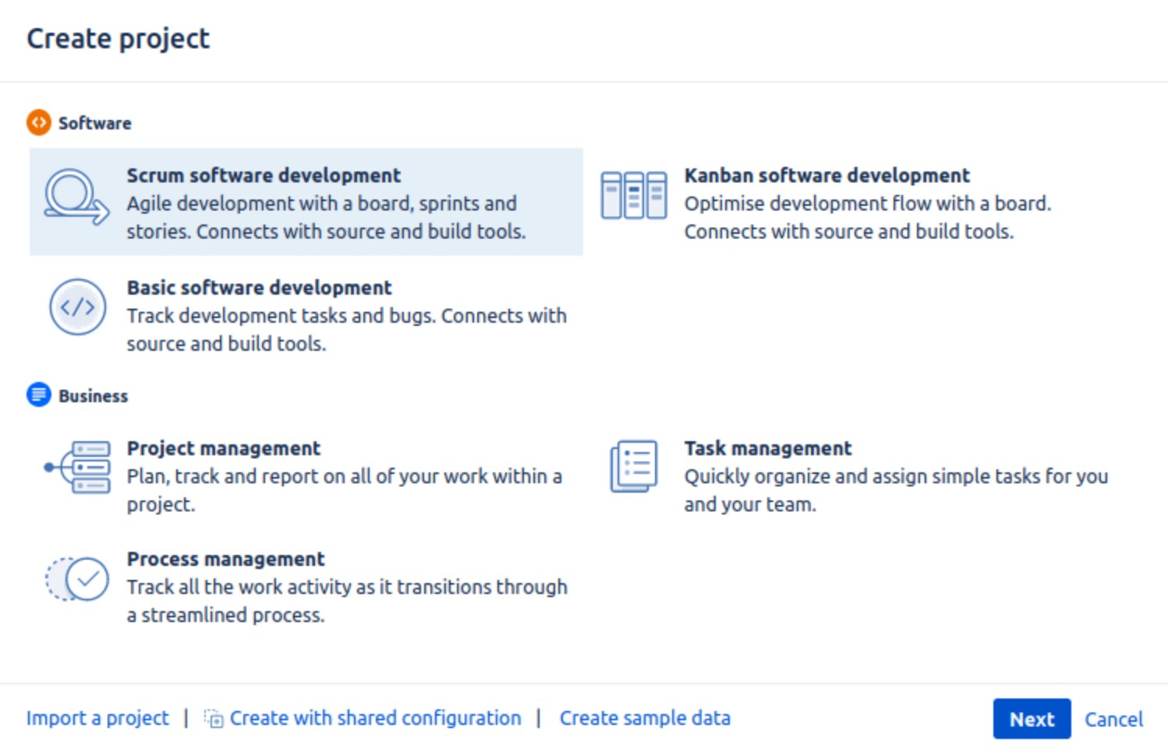

This project includes a Scrum board. For now, you can verify the workflow. You can always change the workflow later.

**What is a Scrum Board?**

A Scrum Board displays issues from one or more projects in columns representing the team's process. They provide the team with a shared view of all work that hasn't started, the work that is in progress, and the work that is completed.

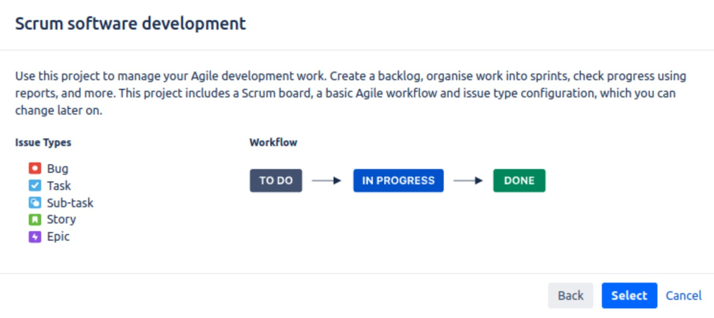

Once you have selected the workflow, then name the project as shown below and then click on **Submit**.

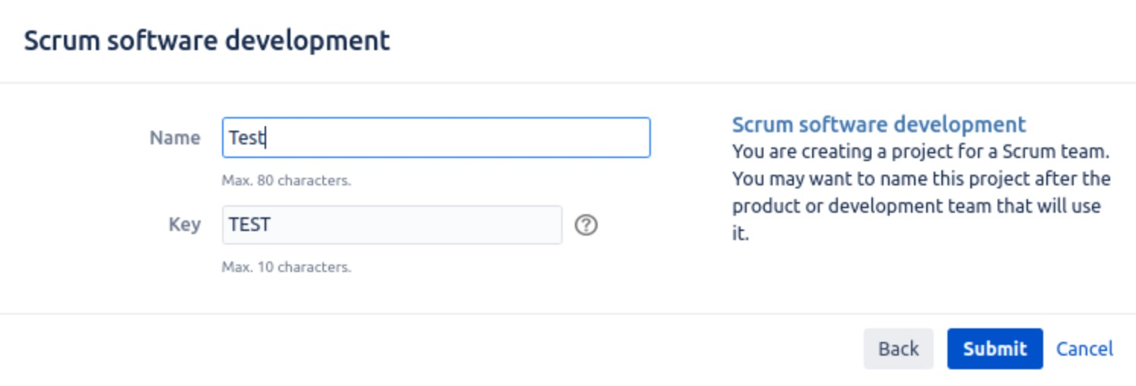

Once the board is set up, you will see your board like shown in the below screenshot.

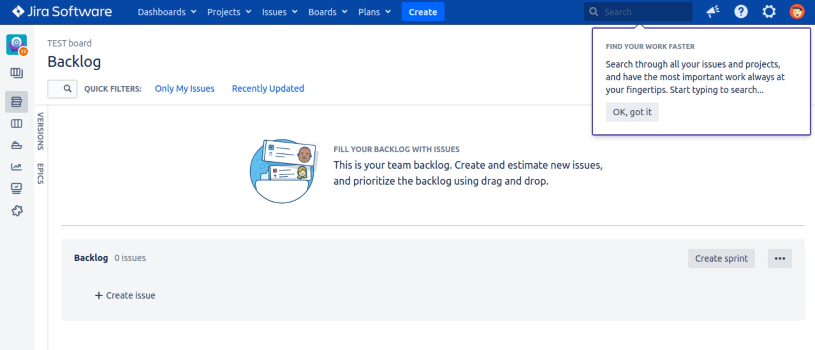

Voila!!

We have completed the setup of a Scrum Software development project using jira Software Data Center.